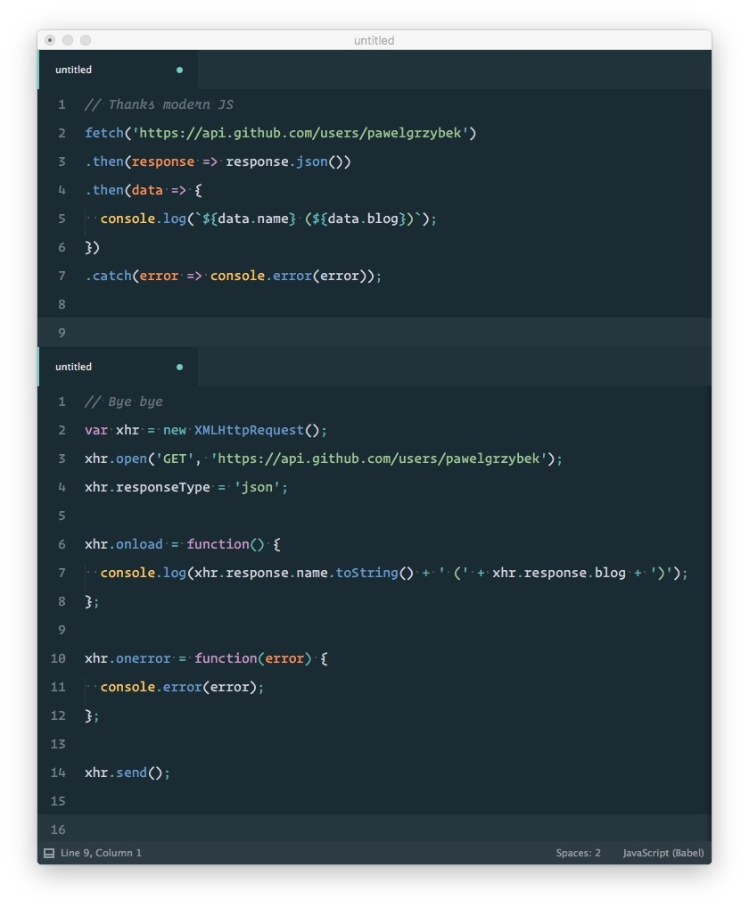

Instead of using Ajax to call API, we can use “Fetch(url)” which is the latest API call in Javascript. Then it will return data which is called “Promise”. We handle data in that promise. However, we can only use data returned in the promise but cant call it outside as global variables. We can just handle data in the promise as local variables.

The convenience of using is that we don’t have much syntaxes in call API. Using Fetch API would make API call easier.